Omninet AI Project – Test Management Artifacts

1. Master Test Plan (IEEE 829 Outline)
Test Plan Identifier: OAI-MTP-v1.0
Date: April 27, 2026
Author: Test Manager
Version: 1.0

1.1 Introduction
This master test plan describes the overall testing strategy for the Omninet AI system, including kiosk (edge), cloud backend, and AI Support Center. It covers all test levels (component, integration, system, acceptance) and aligns with the incremental (backbone) development model.

1.2 Test Items
- Kiosk software (touchscreen UI, AI Assistant, AI Security Agent, sandboxed browser, local cache, payment modules)
- Cloud microservices (API Gateway, Payment Processor, Device Manager, Analytics & Monitoring, AI Orchestrator, AI Model Registry, databases, message queues)
- Support Center web dashboard (human agent interface, AI Monitoring Agent, AI Billing Agent, AI Security Analyst)
- Configuration files, AI models, payment rate tables, content filtering rules

1.3 Features to Be Tested
- All functional requirements from MRD v1.3 (payment, browsing, AI Assistant, localization, session management, administration)
- Non-functional: performance (response times), reliability (uptime, recovery), security (encryption, data wipe, PCI-DSS), usability, supportability (updates)

1.4 Features Not to Be Tested
- Hardware durability testing (covered by manufacturing QA)
- Third-party payment gateway internals (assumed tested by vendor)
- Physical cash acceptor mechanics (covered by hardware supplier)

1.5 Approach
- Incremental backbone integration (Backbone 0 to N)
- Risk-based testing (extensive for high-risk areas, cursory for low)
- Automated regression for critical paths (payment, session, updates)
- Manual exploratory for usability and edge cases
- Test levels executed in sequence: Component → Integration → System → Acceptance
- Tools: JUnit/TestNG (component), Postman/Newman (API), Selenium (UI), JMeter (performance), SonarQube (static analysis), Jira (bug tracking)

1.6 Item Pass/Fail Criteria
- Pass: All high-priority and medium-priority test cases passed; no critical or major open defects.
- Fail: Any critical defect (blocks user workflow) or high-priority defect that affects major functionality.

1.7 Test Criteria

Entry Criteria for System Test (example)
- All component and integration tests passed with ≥95% pass rate.
- No critical defects open against the release candidate.
- Test environment (cloud staging, 5 kiosk simulators) operational.
- Test data (20 languages, sample payment cards) prepared.

Exit Criteria for System Test (example)
- All planned test cases executed (100%).
- Code coverage: ≥80% statement, ≥70% branch for critical modules.
- No open critical/high defects; medium defects ≤5.
- Performance metrics meet MRD v1.3 (payment ≤5 sec, AI response ≤2 sec, welcome reload ≤10 sec).

Suspension/Resumption Criteria
- If a critical defect blocks >20% of test cases, testing suspends until fixed.
- Resumption after fix verified by smoke test.

1.8 Test Deliverables
- Master test plan, level test plans
- Test cases (automated and manual)
- Test logs and defect reports
- Test summary reports for each level
- Release notes

1.9 Test Tasks & Milestones
Task | Duration | Milestone
Component test | 4 weeks | Component sign-off
Integration test (BB0–BB4) | 6 weeks | Backbone complete
System test | 4 weeks | System ready
Acceptance test | 3 weeks | User approval

1.10 Environmental Needs
- Hardware: 5 kiosk prototypes, 2 cloud servers (staging), 2 support center workstations.
- Software: Docker, Kubernetes (minikube), MySQL, MongoDB, Redis, Kafka.
- Network: Simulated 5G/WiFi6, traffic shaping.

1.11 Responsibilities
See organizational chart below.

1.12 Staffing & Training
- 1 Test Manager, 2 Test Leads (edge & cloud), 4 Test Engineers, 1 Automation Engineer, 1 Security Tester, 2 Usability Testers.
- Training: AI model validation, PCI-DSS compliance, accessibility testing.

1.13 Schedule
Activity | Start | End
Component test | Jan 1 | Jan 28
Integration test | Jan 15 | Feb 28
System test | Mar 1 | Mar 28
Acceptance test | Mar 15 | Apr 4

1.14 Risks & Contingencies
Risk | Likelihood | Impact | Mitigation
Late hardware delivery | Medium | High | Use simulators early
AI model underperforms | Medium | High | Fallback to simpler model
Staff shortage | Low | Medium | Cross-train testers

1.15 Approvals
- Product Owner, Development Manager, Test Manager, Quality Assurance Director.

2. Level Test Plan Example: System Test Plan (IEEE 829)
Identifier: OAI-STP-v1.0
Test Level: System Test
Scope: End-to-end validation of fully integrated Omninet AI system (kiosk + cloud + support center) against MRD v1.3 and SysRD v1.0.

2.1 Test Items (System Test Specific)
- Full kiosk software image v1.0
- Cloud microservices (all deployed)
- Support center dashboard (production-like)
- AI models (version 2.1)

2.2 Features to Be Tested
- All user journeys (payment, browsing, AI Assistant, language switching, session termination)
- Admin functions (kiosk monitoring, remote reboot, time modification, termination)
- Non-functional: performance (response times under load), security (encryption, data wipe), reliability (24/7 uptime)

2.3 Entry Criteria (System Test)
- All integration test (Backbone 4) passed with no critical defects.
- Test environment certified: cloud staging, 10 simulated kiosks, 5 support agent workstations.
- All test cases reviewed and approved.
- Smoke test (top 10 critical end-to-end scenarios) passed.
- Defect backlog: zero critical, ≤5 high priority.

2.4 Continuation Criteria (during System Test)
- No test-blocking defect that prevents execution of >20% of remaining test cases.
- Test environment remains stable (no unscheduled downtime >1 hour).
- Build delivery meets daily schedule (by 9:00 AM).
- Daily bug review meeting confirms that fixes are being delivered within 48 hours.

2.5 Exit Criteria (System Test)
- 100% of planned test cases executed.
- Test case pass rate ≥95%.
- No open critical or high-priority defects.
- Medium-priority defects ≤5, all with workarounds documented.
- Performance metrics: payment ≤5 sec (95th percentile), AI Assistant ≤2 sec, welcome reload ≤10 sec.
- Security penetration test: no high-risk vulnerabilities.
- Code coverage (measured on cloud microservices): statement ≥80%, branch ≥70%.
- All exit criteria agreed in System Test Phase Exit Meeting.

3. Entry, Continuation & Exit Criteria for All Test Levels
Test Level | Entry Criteria | Continuation Criteria | Exit Criteria
Component Test | • Code complete for unit  • Unit test harness ready (JUnit)  • No known compilation errors  • Developer smokes test passed | • No blocking defects in component under test  • Test environment stable (local) | • All test cases executed  • Statement coverage ≥90% (critical modules)  • No high-priority defects  • Peer review of test results
Integration Test (Backbone) | • Previous backbone passed  • Interface specifications defined  • Stubs/drivers for missing components ready  • Test environment (sandbox) deployed | • No more than 2 interface failures per day  • Build integration does not break existing tested paths | • All planned integration test cases passed  • Message exchange latency ≤100 ms  • No unresolved interface defects  • Integration test summary report approved
System Test | See section 2.3 | See section 2.4 | See section 2.5
Acceptance Test | • System test exit passed  • User representatives identified  • Acceptance test cases approved by product owner  • Production-like environment (pilot location) | • User feedback does not reveal critical showstoppers  • Beta participants can complete core tasks | • All acceptance criteria (SUS ≥70, task completion ≥85%) met  • No unresolved critical usability issues  • Sign-off from customer representative

4. Organizational Chart with Responsibilities
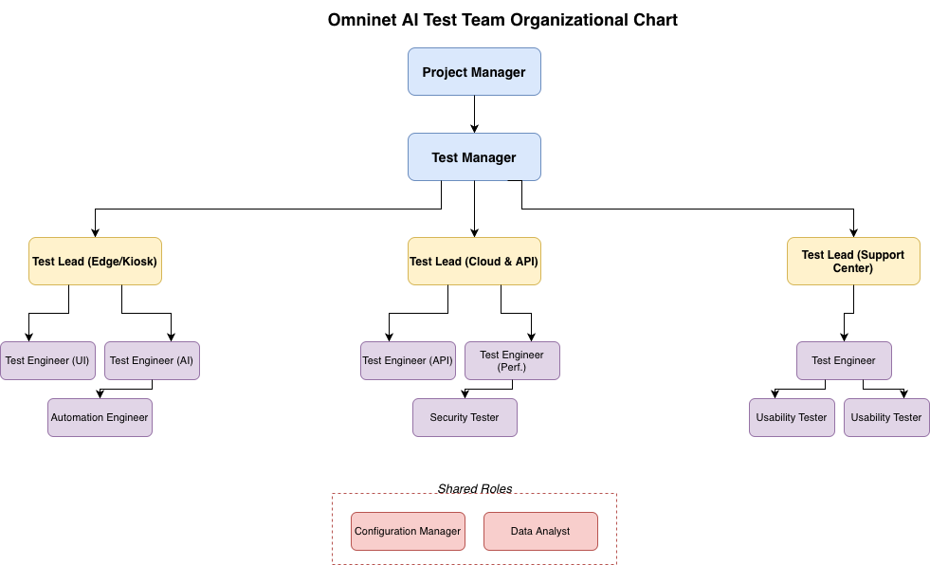

Responsibilities
Role | Responsibilities
Test Manager | Overall test strategy, master test plan, budget, resource allocation, stakeholder reporting, risk management.
Test Lead (Edge) | Component & integration test for kiosk; manage kiosk test environment; report edge-related defects.
Test Lead (Cloud) | API, microservices, performance, security testing; cloud test environment; coordinate with DevOps.
Test Lead (Support Center) | Usability testing, acceptance testing, beta test coordination; manage user feedback.
Test Engineer | Write and execute test cases, log defects, automate regression scripts, maintain test data.
Automation Engineer | Build and maintain CI/CD test pipelines (Jenkins), develop test frameworks.
Security Tester | Penetration testing, vulnerability scanning, PCI-DSS compliance verification.
Usability Tester | Plan and conduct usability tests, analyse SUS scores, produce UX reports.
Configuration Manager | Version control for testware, test item transmittal, build release management.

5. Cost Estimation for Omninet AI Testing

Assumptions
- Project duration: 4 months (Jan–Apr 2026) for test execution.
- Team size: 12 people (including test manager, leads, engineers).
- 1,000 kiosks to be deployed after acceptance; cloud supports 10,000 concurrent.
- Tools: open-source where possible, some commercial licenses.

5.1 Effort (Person-Months)
Activity | Person-Months | Notes
Test planning & master test plan | 1.5 | Test manager + leads
Component test design & execution | 4 | 2 test engineers × 2 months
Integration test (backbone) | 6 | 3 test engineers × 2 months
System test (functional, performance, security) | 8 | 4 test engineers × 2 months
Acceptance & usability testing | 4 | 2 test engineers + 2 usability × 1 month
Automation development | 2 | 1 automation engineer × 2 months
Test environment setup & maintenance | 2 | 1 config manager + 1 sysadmin × 2 months
Defect management, reporting, meetings | 2 | All team (overhead)
Total | 29.5 person-months

5.2 Cost Breakdown (USD)
Category | Cost | Calculation
Salaries (loaded) | $354,000 | 29.5 pm × $12,000/pm average
Test tools | $25,000 | JMeter (free), Selenium (free), Jira ($10k),SonarQube($5k), LoadRunner ($10k)
Test environment (cloud) | $15,000 | AWS/GCP for 4 months (staging + load tests)
Hardware (5 kiosk prototypes) | $10,000 | $2,000 each
User recruitment for usability | $5,000 | 20 participants × $250
Training (AI security, PCI-DSS) | $8,000 | Online courses, certifications
Contingency (15%) | $62,550 | (354k+25k+15k+10k+5k+8k)×0.15
Total estimated test cost | $479,550

5.3 Comparison to Development Cost (Illustrative)
- Estimated total project development cost: $2.5M
- Testing cost proportion: ~19% → within industry typical range (15–25% for critical systems).

5.4 Cost per Kiosk (Amortised over 1,000 units)
- Testing cost per kiosk = $479,550/1,000=**$480 per kiosk** (one-time)
- This is reasonable given the high reliability and security requirements of public kiosks.

6. References
- Omninet AI MRD v1.3
- Omninet AI SysRD v1.0
- IEEE 829-2008 Standard for Software Test Documentation
- Risk analysis (previous section)
These artifacts provide a complete test management framework for the Omninet AI project, ready for implementation.

